**NAAN MUDHAVAN**

**ASSIGNMENT DOCUMENT**

**COURSE TITLE** : DIGITAL MARKETING

**COLLEGE CODE** : 1105

**COLLEGE NAME** : GOJAN SCHOOL OF BUSINESS AND TECHNOLOGY

**NM ID :**3C1A9BFF139D1A0930149115E898A3E1

**NAME** : AJAY S

**REGISTER NUMBER** : 110520106303

**YEAR** : 4TH YEAR

**DEPARTMENT** : ELECTRONICS AND COMMUNICATION ENGINEERING

1. Create a blog or website using Blogspot and Wordpress. Customize the theme design and post new article with 500 words.

Link: <https://culinaryskills2023.blogspot.com/2023/10/the-culinary.html>

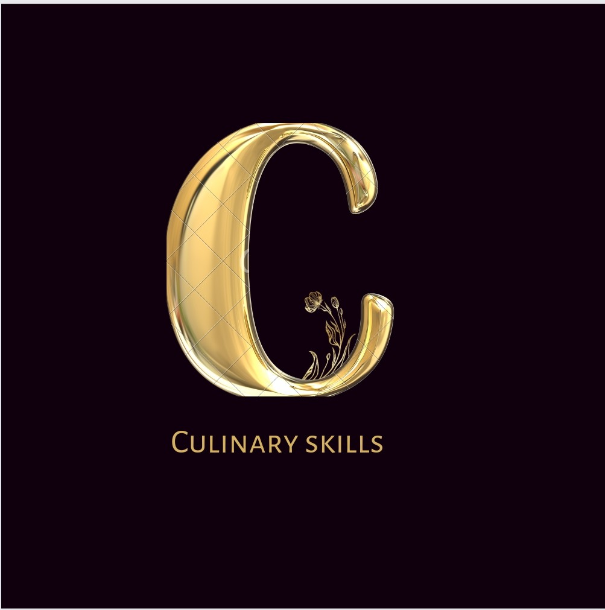

2.Create a New Facebook Business Page and post one social media poster for your brand.

Link: <https://culinaryskills2023.blogspot.com/2023/10/the-culinary.html>

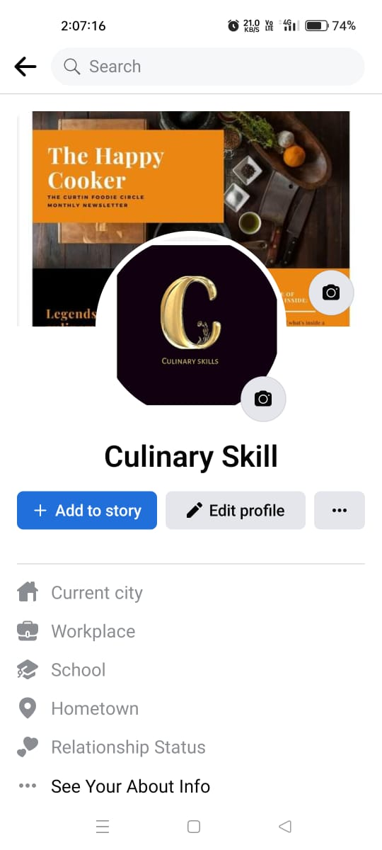

3.Create and design a social media advertisement poster using canva.

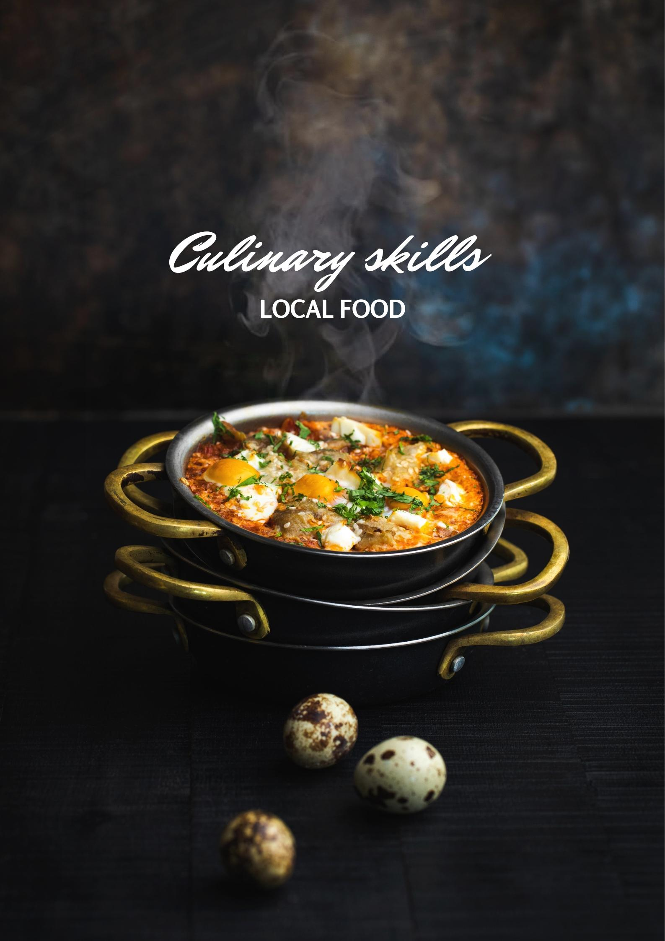

1. Create email newsletter design using MailChimp or canva tool.

Link: <https://culinaryskills2023.blogspot.com/2023/10/culinary-style.html>

